AJ Ricketts

Prof Mengchi Liu

Saturday October 19th, 2019

COMP 3005 Assignment #4

**Part 1:**

**Part 2:**

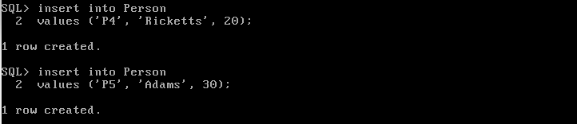

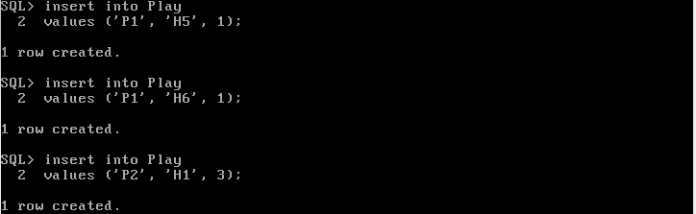

**And then I could continue on populating the table:**

**Part 3:**

**Question 1:**

**Question 3:**

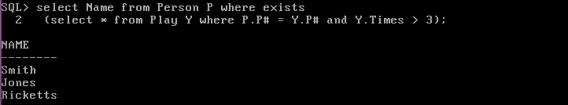

**Question 4:**

**Question 5:**

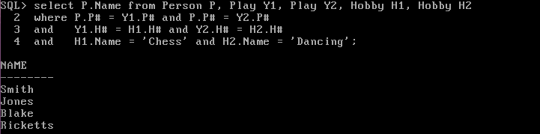

**Question 7:**

**Question 8:**

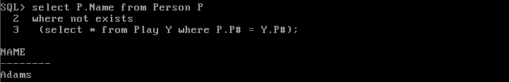

**Question 9:**

**Question 10:**

**Question 11:**

**Question 12:**

**Question 13:**

**Question 14:**

**First had to create a temp table that had the names and the number of hobbies they played:**

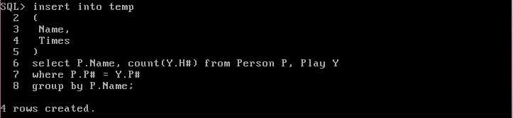

**Then found the Names of the people with the least number of hobbies:**

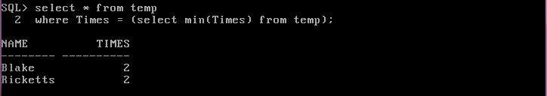

**Then Dropped the table:**

